

**Report on Special Assistance at George Best Belfast City Airport**

May 2022

**Contents**

**1.** **EXECUTIVE SUMMARY** 2

**2. INTRODUCTION** 2

**3.** **METHODOLOGY** 4

**4.** **FINDINGS** 4

**5.** **CONCLUSIONS** 13

**6.** **NEXT STEPS** 13

**Annex 1** **Summary of Recommendations** 15

# **1. EXECUTIVE SUMMARY**

1.1 European Regulation (EC) 1107/2006 (the Regulation) provides rights for passengers with disabilities and reduced mobility when travelling by air. This has been retained in United Kingdom (UK) law following the UK’s exit from the European Union (EU).

1.2 The Regulation requires all airports and airlines in the UK and EU to provide assistance to passengers with a disability or reduced mobility. The Consumer Council has been designated by the Civil Aviation Authority (CAA) to be the complaints handling body for the Regulation.

1.3 In 2014 the CAA issued guidance requiring airports to consult with passengers with a disability or reduced mobility. This report details the findings of a meeting on 4 April 2022 of the George Best Belfast City Airport’s (GBBCA) Accessibility Forum which involved a tour of the airport building. The Forum is made up of a range of organisations which represent consumers with a disability or reduced mobility.

1.4 The Forum was very positive about the airport’s facilities and, in particular, the special assistance services that are provided to passengers right through from the initial car park call points to departures. There were a number of recommendations made by participants. These focussed on:

* Signage;
* Colour contrasting on escalators/steps;
* Improvements to seating areas.

1.5 The findings of the visit will be shared with the airport. An update on progress made against the recommendations will be reported by the airport to the Accessibility Forum at its next meeting.

# **2. INTRODUCTION**

2.1 In 2006 European Regulations[1] came into place that require all airports and airlines in the EU to assist passengers with a disability or with a reduced mobility (PRM)[2] when travelling. These have been retained and written in UK law since its exit from the EU[3]. Airlines licensed in the EU, operating flights from a non-EU country into the EU must also assist passengers.

2.2 The Consumer Council has been designated by the CAA as the complaints handling body for the Regulation[4] relating to an airport in Northern Ireland or a flight departing from a Northern Ireland airport. The Consumer Council works alongside the Northern Ireland airports to ensure that their services continue to meet passengers’ needs.

2.3 In 2014 the CAA issued guidance requiring airports to consult with passengers with a disability or reduced mobility. This *‘should, as much as possible, include practical inspections of airport services (generally using ‘walk throughs’)*. *Airports should also consider convening regular forums containing representatives of disability groups and individuals’*

2.4 In 2018, the Consumer Council worked with GBBCA to establish an Accessibility Forum at the airport. Membership of the Accessibility Forum consists of a range of organisations that represent consumers with a disability or reduced mobility.[5] The aim is to provide a forum for users of the Airport’s Special Assistance services or their representatives to share their knowledge and experiences of services at the airport.

2.5 The Accessibility Forum toured the airport facilities on 31 January 2019. Forum members provided feedback on the facilities and services and identified possible changes that could further assist air passengers with a disability or reduced mobility. A follow up meeting was held in January 2020 and the airport has since implemented a number of recommendations made by participants.

2.6 Due to Covid-19 restrictions, no meeting of the Accessibility Forum took place in 2021.

2.7 The intended outcome of this visit is for the Forum to continue to work with the airport in looking specifically at special assistance to gain a better understanding of issues faced by passengers using this service. In particular, it is intended to identify areas where it works well, and to implement suggestions made by forum members to help make travel more convenient for those passengers. The airport will provide feedback on actions taken from the recommendations made at the next forum meeting.

2.8 GBBCA and the Consumer Council would like to thank those participants who took part on the day.

# **3. METHODOLOGY**

3.1 The Forum met at the airport on 4 April 2022. There were five participants from a range of organisations that represent consumers with a disability or reduced mobility.

3.2 The forum was split into two groups and airport staff guided each group through the airport beginning at the check-in area and finishing in the arrivals areas.

3.3 Staff from the Consumer Council took notes at the visit and recorded the recommendations that were made by the group.

# **4. FINDINGS**

4.1 The following section provides a summary of the key discussion points that were recorded with corresponding recommendations. The findings are set out in the order of the various stages of moving through the airport, with an overall summary provided at Annex 1.

Arrival at the airport/parking area

4.2 At the beginning of the tour the group discussed the various ways that a passenger could arrive at the airport and the assistance points that were available. There was good signage at the car park to disabled parking bays and clearly marked special assistance points (Figure 1). Airport staff explained that, on booking special assistance, passengers can avail of the short stay car park at the long stay rate in all circumstances no matter how long their stay would be. Call assistance points were also available at all entrances and exits. It was suggested that a sign would be useful alongside these to assist deaf or hard of hearing visitors.

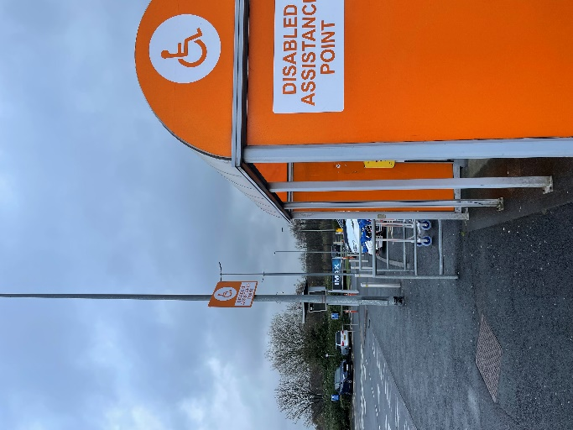

Figure 1: Disabled assistance point

**Recommendation:**

* Review signage on call assistance points to ensure people who are deaf or hard of hearing are aware that a member of staff will come out if the button is pressed.

Entrance/Departures area

4.3 Participants said that when entering through the airport main doors it is not obvious where the special assistance desk is located, as it is not referred to on the signage (Figure 2). The desk was also obscured by a tourism information area. The area itself was well equipped with a clearly labelled call point and low desk (Figure 3). Seating in this area is currently grey but will be made a contrasting brighter/different colour. A “Changing Places” toilet facility is available by the check-in desks, however this is not referred to in any signage in the departures area.

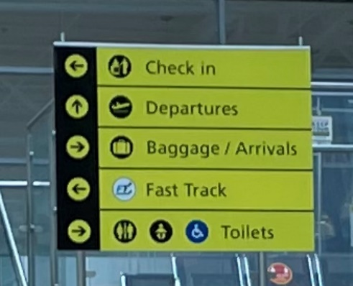 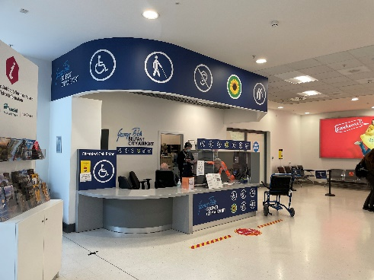

Figure 2: Signage at entrance Figure 3: Special assistance desk

**Recommendations:**

* Provide clear signage to the special assistance desk at entrance/departures area.
* Consider location of special assistance desk so that it is not hidden behind other information areas – could it be located nearer to the check-in area?
* Provide signage to indicate the availability of a Changing Places toilet.

Check-in area

4.4 The check-in area was generally well spaced-out and signposted, however participants noted that check-in desk numbers were grey on a white background and did not stand out. The desks were also very high which could pose problems in particular for wheelchair users.

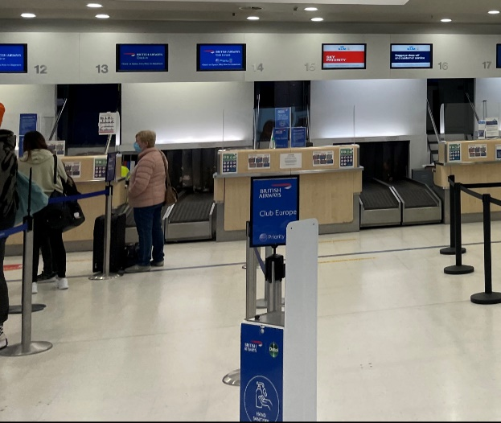

Figure 4: Check-in area

**Recommendations:**

* Check-in desk numbers should be black on a white background, with a matt finish if possible to prevent glare.
* Consider height of desks or signpost to an alternative area where check in can take place if this is an issue for individual passengers.

Security area

4.5 Passengers requiring special assistance could avail of a fast-track lane through security. The area was generally quiet with clear walls not overloaded with information. Airport staff are trained to ask passengers how they can be best assisted, without making assumptions. The seating area after security checks, where passengers can gather their belongings and put shoes, coats etc. back on was obscured from view by a number of desks. A range of hand sanitising stations, clearly signed and at different heights, were available and praised by participants.

**Recommendation:**

* Make seating area immediately after security more visible.

4.6 The escalator immediately after security had yellow lines on individual steps. It was noted that contrasting colours should also be provided at the top and bottom to indicate the start and finish of a moving walkway. A series of black dots marked the top of the staircase; these should be replaced with a yellow strip to provide more clarity.

**Recommendation:**

* Place yellow strips at top and bottom of escalator and steps.

Gate area

4.7 Participants welcomed the availability of an alternative, quiet route to the gate areas to passengers who wished to avail of it; this would mean avoiding the duty free area with associated noise and smells. Participants commented positively on the large, eye-level screen displaying flight departures (Figure 5). Signage to the departures area was clearly contrasted (black on yellow), however it would be useful to have additional signage at eye level (Figure 6).

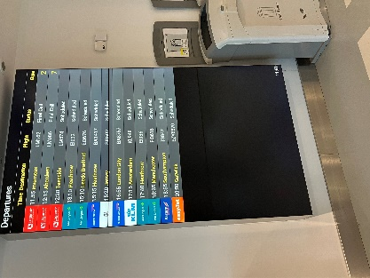 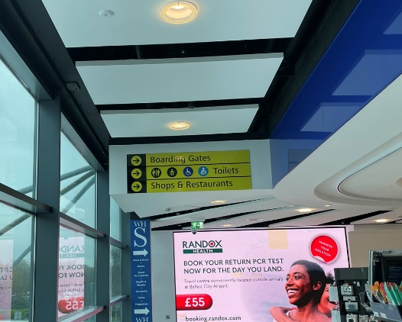

Figure 5: Flight display screen Figure 6: Signage to gates/shops

**Recommendation:**

* Consider additional signage at eye level to gates/shops.

4.8 Participants noted white and black flooring in the departures area (Figure 7). This could cause issues particularly to people with dementia or autism, making them reluctant to cross as they may think there is a hole or a step up. In addition, a matt finish is preferable to gloss and a “sparkly” finish should be avoided as this is not helpful to passengers with visual impairments.

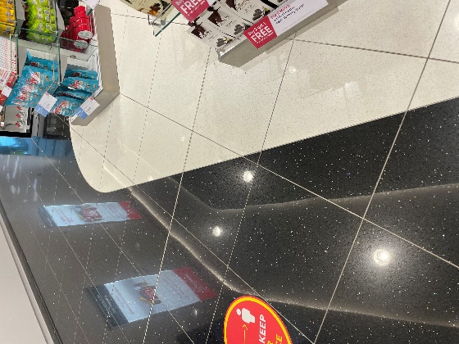

Figure 7: Flooring in shopping area

**Recommendation:**

* Consider better contrasting floor colours with a matt finish.

4.9 Toilets in the gate area were very well signposted (Figure 8) and the assistance toilet was considered to be well equipped and spacious. One participant commented that push button operated flushes were more difficult for people with mobility issues, and that contrasting colours for toilet seats and handles are preferable for people with dementia.

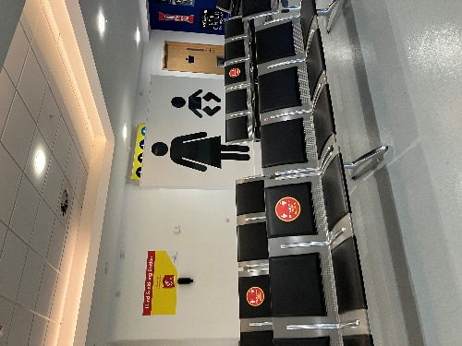 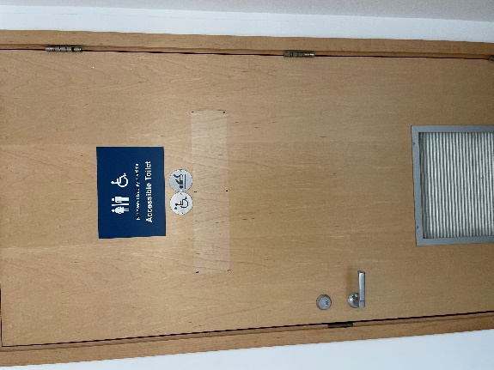

Figure 8: Toilets in gate area Figure 9: Assistance toilet

**Recommendations:**

* Provide larger signage with regards to hidden disabilities on assistance toilets.
* Consider providing contrasting colours for toilet seat/handles to assist people with dementia or visual issues.
* Consider replacing push button flush with handle.

4.10 There is a clearly signed assisted travel reserved seating section in the departures area – this is sometimes manned at busy times. Participants were in general impressed at the size and placement of the area. However, compared to other work/business seating sections nearby, it was considered to be in need of some updating to make the area more welcoming and modern. In addition, the lighting in the section could be improved as there was no natural light coming in. Information should continue to be kept to a minimum e.g. on walls and seats should be in contrasting colour to wall/floor.

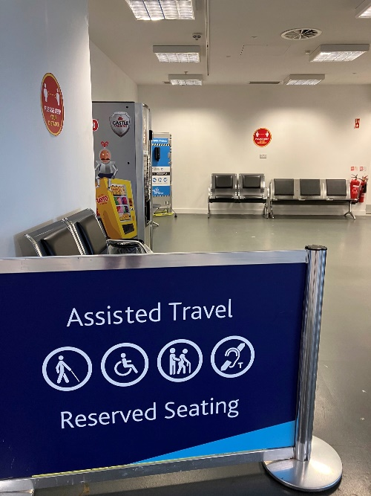

Figure 10: Assisted Travel Seating Area

**Recommendation:**

* Update assisted travel seating area in line with improvements to other sectioned areas to ensure it is as welcoming as possible to passengers.

4.11 A separate work/charging area was complimented by participants as being very accessible. A specific area of good practice was the presence of a contrasting yellow/white charge point which is particularly helpful to passengers with a visual impairment compared to completely white colouring (Figures 11 and 12).

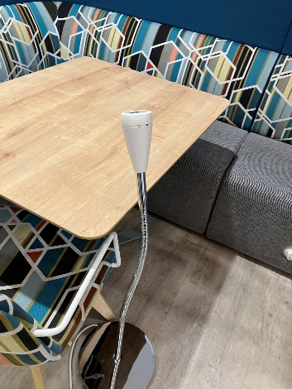 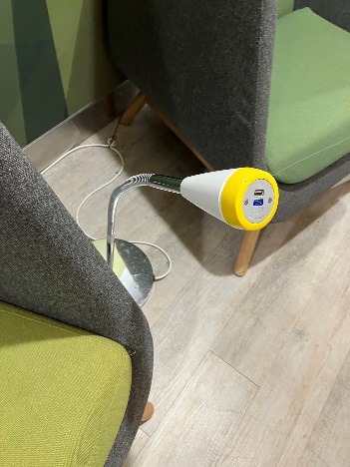

Figure 11: White charging point Figure 12: Yellow/white charging point

4.12 The Danske Bank seating area was also complimented on its accessibility and modern feel, however the drop lighting may cause sensitivity issues, for example affecting people with autism (Figure 13). The Aspire Lounge again was praised for its spaciousness and facilities, although it was noted that the entrance door was quite heavy and difficult to open.

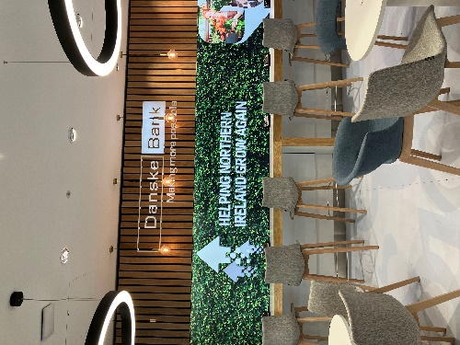

Figure 13: Danske Bank seating area

**Recommendations:**

* Consider changing lighting mode in Danske Bank section.
* Consider an automatic door to Aspire Lounge.

4.13 The restaurant areas were again praised for spacing and accessibility, however it was unclear if there was sufficient space for wheelchair users to sit at the tables.

**Recommendation:**

* Restaurant operators to audit space to ensure full accessibility for people with mobility issues.

4.14 There are further toilet facilties beyond the restaurant areas. It would be useful if these could be signposted from the main gate area as participants were unaware that there were additional toilets. This would be particularly beneficial if the airport was very busy. The signage was also very high up and participants agreed it would be better to provide additional signage at eye level, particularly along the corridor to the additional facilities (Figures 14 and 15).

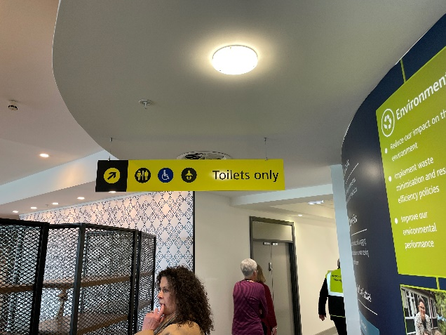 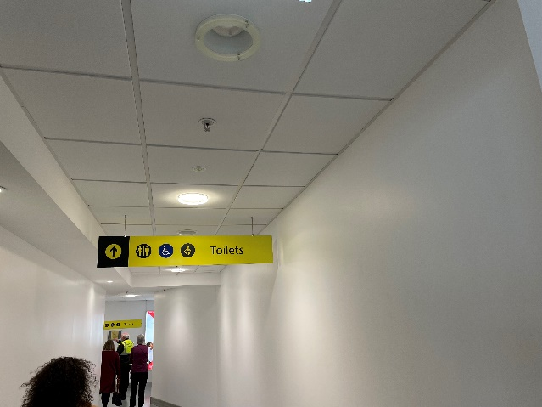

Figure 14: Additional toilets Figure 15: Signage in toilet corridor

**Recommendations:**

* Provide signage at an earlier point in gate area advising passengers of additional toilet facilities.
* Provide additional signage at eye level directing passengers to toilets.

4.15 Airport staff noted that there had been plans to install a quiet/sensory room but these had been stalled due to Covid-19. Passengers needing a quieter space, particularly when the airport is very busy, can go through the doors by Gates 1-3 and 5-10. Participants also noted the presence of a “multi faith prayer room” in the arrivals hall, although this was locked at the time of the visit.

4.16 Participants proceeded to the gate area down a series of steps. These should have yellow strips at the top and bottom (Figure 16). A lift was also available. It was noted that the queue poles for the gate areas are grey, the same colour as the carpet – it would be better if these could be in contrasting colours.

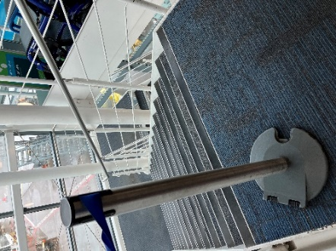

Figure 16: Steps down to Gates 1-3 and 5-10.

**Recommendations:**

* Insert yellow strips at the top and bottom of all steps in the airport.
* Change colours of queue poles so that they contrast more clearly with the floor/walls.

4.17 Participants then headed towards international arrivals. Once again clear signage in contrasting colours was praised. Border Control was uncluttered with walls only containing necessary information. Posters welcoming the sunflower lanyard were also praised.

4.18 Coming into domestic arrivals, there was clear perspex around the police stands which was not clearly marked. This was noted as a potential hazard for visually impaired passengers. One participant noted that the baggage reclaim desk was high, however airport staff explained that staff can come out and speak to passengers as necessary. The amount of seating in this area was praised, and the large signage on the baggage reclaim belts was very clear. The toilet facilties were also clearly signposted.

**Recommendation:**

* Provide markings at police stands to note clear perspex surrounds.

# **5. CONCLUSIONS**

5.1Participants welcomed the opportunity to tour the airport and expressed satisfaction throughout at the processes and changes that had been implemented already to improve the experience for passengers requiring special assistance. Participants were able to ask questions throughout the visit and make suggestions based on their experiences and knowledge of some of the barriers passengers may face. A number of recommendations were made around signage; the need for more contrasting colours on escalators and steps and improvements to seating areas.

# **6. NEXT STEPS**

6.1 The comments made by participants will be presented to the airport through this report. The Consumer Council will work with the airport as it implements the changes to ensure that services continue to meet passengers’ needs. An update on the progress made against the recommendations will be shared with the Airport’s Accessibility Forum at its next meeting.

# **Annex 1 Summary of Recommendations**

|  |  |
| --- | --- |
|  | **Signage** |
| 1 | Review signage on call assistance points to ensure people who are deaf or hard of hearing are aware that a member of staff will come out if the button is pressed.  New sign to be put on assistance points |
| 2 | Provide clear signage to the special assistance desk at entrance/departures area.  Signage to be added to existing signage as you enter the terminal |
| 3 | Provide signage to indicate the availability of a Changing Places toilet.  There is already information on the Changing Places website and also on the Accessible link on our website that includes |
| 4 | Check-in desk numbers should be black on a white background, with a matt finish if possible to prevent glare.  Our focus is on displaying the airline logos and they are very clear with our backdrop screens at check in |
| 5 | Consider additional signage at eye level to gates/shops.  We are conscious of issues within our busy environment whereby signage could be obscured |
| 6 | Provide signage at an earlier point in gate area advising passengers of additional toilet facilities near the restaurant area.  This will be kept under review |
| 7 | Provide larger signage with regards to hidden disabilities on assistance toilets.  This will be addressed very soon |
| 8 | Provide additional signage at eye level directing passengers to toilets.  We are conscious of issues within our busy environment whereby signage could be obscured |
| 9 | Provide markings at police stands in arrivals area to note clear perspex surrounds.  We will draw this to the attention of the PSNI for their views – it is most likely a temporary measure |
|  | **Special Assistance Desk** |
| 10 | Consider location of special assistance desk so that it is not hidden behind other information areas – could it be located nearer to the check-in area?  The desk will be returned to its original location within the next few weeks and this will mean that it is much closer to check in |
|  | **Check-in area** |
| 11 | Consider height of desks or signpost to an alternative area where check in can take place if this is an issue for individual passengers.  There is due to be a refreshment programme carried at check in so this is duly noted and will be advised |
|  | **Seating** |
| 12 | Make seating area immediately after security more visible.  The seating at security is due to be re-arranged |
| 13 | Update assisted travel seating area in line with improvements to other sectioned areas to ensure it is as welcoming as possible to passengers.  Currently a temporary arrangement due to reduced passenger numbers The area is due to be relocated |
| 14 | Consider changing lighting mode in Danske Bank section.  This will be referred to Danske Bank |
|  | **Escalators/steps** |
| 15 | Insert yellow strips at the top and bottom of all steps in the airport.  This request has been passed on to our Facilities manager |
|  | **Contrasting Colours** |
| 16 | Consider better contrasting floor colours with a matt finish in shopping area.  The flooring in WDF is a brand used in all airports they operate from |
| 17 | Consider providing contrasting colours for toilet seat/handles to assist people with dementia or visual issues.  We will keep this in mind for any future refurbishments |
| 18 | Change colours of queue poles so that they contrast more clearly with the floor/walls.  There is a plan for refurbishment that will include a change to carpeting that will provide the required contrast in colour schemes |
|  | **Toilets** |
| 19 | Consider replacing push button flush with handle in assistance toilets.  Noted and will suggest for future refurbishments |
|  | **Lounges/Restaurant areas** |
| 20 | Consider an automatic door to Aspire Lounge.  The Aspire lounge is due to be refurbished next year – it is also staffed whilst open so assistance is always available |
| 21 | Restaurant operators to audit space to ensure full accessibility for people with mobility issues.  We have been in contact the restaurant managements so that they can be mindful of best practice for passengers needs |

1. European Regulation (EC) 1107/2006
2. People of Restricted Mobility (PRM)
3. Regulation (EC) No 1107/2006 (as amended by The Air Passenger Rights and Air Travel Organisers’ Licencing (Amendment) (EU Exit) Regulations 2019)
4. Civil Aviation (Access to Air Travel for Disabled Persons and Persons with Reduced Mobility) Regulations 2007 (SI 2007/1895)
5. IMTAC, Autism, Royal National Institute of Blind People (RNIB), Urostomy Association, JAM Card