

Report on Special Assistance at Belfast City Airport

  - Consumer Council for Northern Ireland
  - 26 November 2024
Table of contents

Executive Summary 2
Introduction 3
Methodology 4
Findings 5
Arrival at the airport/parking area 5
Entrance/Departures area 6
Security area 8
Gate area 9
Conclusion 17
Next Steps 17
Annex 1 Summary of Recommendations 18

Executive Summary
European Regulation (EC) 1107/2006 (the Regulation) provides rights for
passengers with disabilities and reduced mobility when travelling by air. This has
been retained in United Kingdom (UK) law following the UK’s exit from the European
Union (EU).

The Regulation requires all airports and airlines in the UK and EU to provide assistance to passengers with a disability or reduced mobility. The Consumer Council has been designated by the Civil Aviation Authority (CAA) to be the complaints handling body for the Regulation.

In 2014 the CAA issued guidance requiring airports to consult with passengers with a disability or reduced mobility. This report details the findings of a meeting on 26 November 2024 of Belfast City Airport’s Accessibility Forum which involved a tour of the airport building. The Forum is made up of a range of organisations which represent consumers with a disability or reduced mobility.

The Forum was very positive about the airport’s facilities, particularly the special assistance services that are provided to passengers. The Forum was appreciative of the efforts the airport had made to implement the suggestions made during the previous year’s visit, many of which had already been put in place. There were a number of recommendations made by participants. These focussed on:

- Placement of items in the accessible toilets and improvements to the braille signage on all accessible toilet doors.
- Special assistance seating.
- Colour contrasting on the intercom outside the airport building, chairs, doors/door frames, and steps throughout the airport.
- Improvements to Aspire Lounge and toilet facilities.
- Further improvements to signage.
- Updates to the airport website to improve awareness of airport's special assistance contact number.

The findings of the visit will be shared with the airport. An update on the progress made against the recommendations will be reported by the airport to the Accessibility Forum at its next meeting.

Introduction
In 2006 European Regulations (European Regulation (EC) 1107/2006) came into place that require all airports and airlines in the EU to assist passengers with a disability or with a reduced mobility (PRM) when travelling. These have been retained and written in UK law since its exit from the EU (Regulation (EC) No 1107/2006, as amended by The Air Passenger Rights and Air Travel Organisers’ Licencing (Amendment) (EU Exit) Regulations 2019). Airlines licensed in the EU, operating flights from a non-EU country into the EU must also assist passengers.

The Consumer Council has been designated by the CAA as the complaints handling body for the Regulation (Civil Aviation (Access to Air Travel for Disabled Persons and Persons with Reduced Mobility) Regulations 2007 (SI 2007/1895)) relating to an airport in Northern Ireland or a flight departing from a Northern Ireland airport. The Consumer Council works alongside the Northern Ireland airports to ensure that their services continue to meet passengers’ needs.

In 2014 the CAA issued guidance requiring airports to consult with passengers with a disability or reduced mobility. This ‘should, as much as possible, include practical inspections of airport services (generally using ‘walk throughs’). Airports should also consider convening regular Forums containing representatives of disability groups and individuals.’

In 2018, the Consumer Council worked with Belfast City Airport to establish an Accessibility Forum at the airport. Membership of the Accessibility Forum consists of a range of organisations that represent consumers with a disability or reduced mobility including IMTAC, Royal National Institute of Blind People (RNIB), Guide Dogs for the Blind Association NI, Urostomy Association and Disability Action. The aim is to provide a Forum for users of the Airport’s Special Assistance Services or their representatives to share their knowledge and experiences of services at the airport.

The intended outcome of this visit is for the Forum to continue to work with the airport in looking specifically at special assistance to gain a better understanding of the issues faced by passengers using this service. In particular, it is intended to identify areas where it works well, and to implement suggestions made by forum members to help make travel more convenient for those passengers. The airport will provide feedback on actions taken from the guidance and suggestions made at the next Forum meeting.

Belfast City Airport and the Consumer Council would like to thank those participants who took part on the day.

Methodology
The Forum met at the airport on 26 November 2024. There were ten participants on the day from a range of organisations that represent older consumers and consumers with a disability or reduced mobility.

The forum was split into three groups and airport staff guided each group through the airport beginning at the check-in area and finishing in the arrival areas.

Staff from the Consumer Council took notes at the visit and recorded the suggestions that were made by the group.

Findings
The following section provides a summary of the key discussion points that were recorded with corresponding suggestions. The findings are set out in the order of the various stages of moving through the airport, with an overall summary provided at Annex 1.

Arrival at the airport/parking area
Airport staff noted that blue badge holders can avail of the short stay car park at the long stay rate in all circumstances no matter how long their stay would be.

The Intercom for assistance at the drop-off area, located within the shelter, is not clearly visible. The sign appears to blend into the shelter’s yellow background (Figure 1). The intercom is currently positioned at the end of the shelter but moving it to the end of the zebra crossing may be beneficial. While a telephone number is available at the call assistance points for those who wish to call, individuals choosing to wait in the car will not have the ability to utilise the intercom system (Figure 2).

Figure 1: Assistance point and intercom

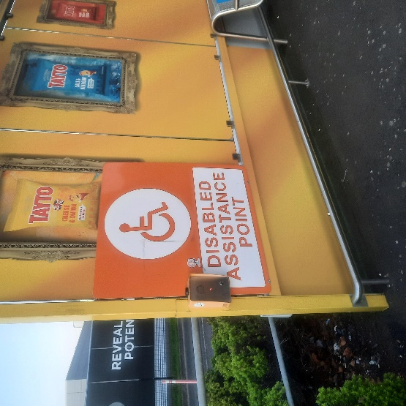

Figure 2: Zebra crossing to shelter

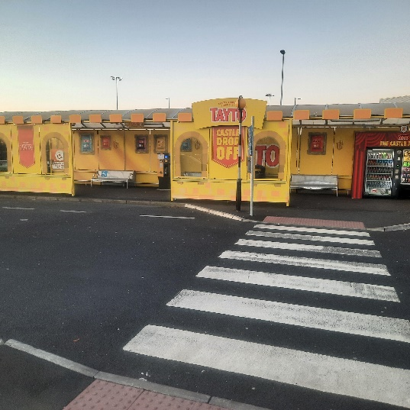

Recommendations:

- Consider changing the colour of the “Disabled Assistance Point” sign to blue. This would contrast well with the yellow background.
- Consider moving the intercom to the entrance to the shelter (end of zebra crossing). Alternatively, provide additional signage at this point indicating the location of the existing push button or install an additional push button at the zebra crossing located at the end of the shelter.
- Add the telephone number for assistance to the airport website. This would be particularly beneficial for those who are unable to use the intercoms while waiting in the car.

Entrance/Departures area
The group noted the changes made to the assistance desk following a previous recommendation. This has been moved to a more central and visible location that is closer to the entrance. The desk has been renamed Disability Services, which the group thought provided clarity (Figure 3). Forum members welcomed the changes, including the low-level counter for wheelchair users.

Figure 3: Disability Services desk

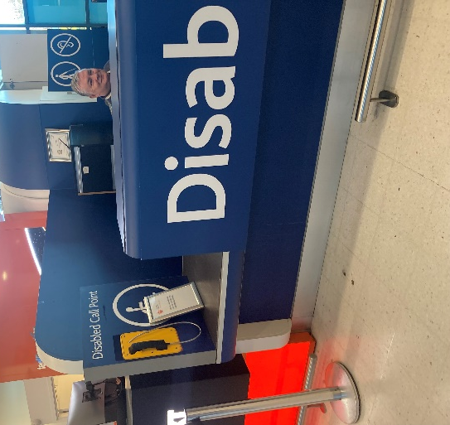

Recommendation:

- Consider amending the main signage visible through the entrance doors to include the location of the Disability Services desk.

The bank of car hire desks do not have lowered desks for wheelchair accessibility. This contrasts with a separate car hire desk that does include a lower accessible desk (Figure 4). Airport staff confirmed that changes to the car hire desks will be made soon.

Figure 4: Car hire desks

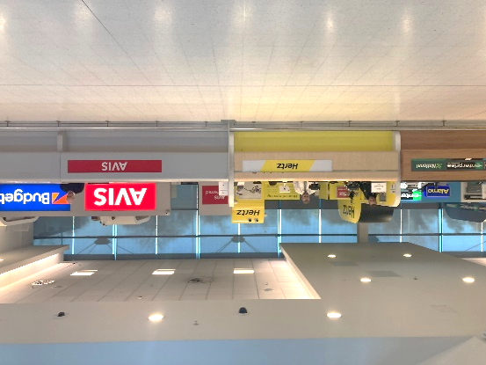

Recommendation:

- Consider provision of a lowered desk at each service provider to improve accessibility for all users.

The group noted the new assisted travel seating area opposite the Disability Services desk. Forum members welcomed this change and stated how useful it is opposite the Disability Services desk (Figure 5).

Figure 5: Assisted travel seating area

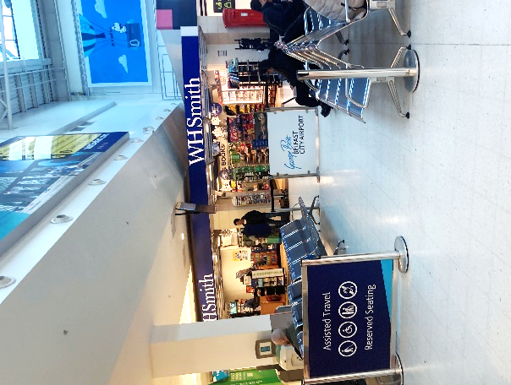

Recommendation:

- Add additional arms (which can move up and down) to the seats in the assisted travel seating area to improve accessibility and comfort.

Security area
Passengers requiring special assistance could avail of a fast-track lane through security. The area appears spacious. Airport staff highlighted the new security scanners and confirmed that a verbal description would be provided to passengers with sight loss when using the body scanner. Forum members stated that the instructions may be difficult for passengers with sight loss and for those with autism in relation to touch. Forum members emphasised that a passenger’s stoma bag would appear in the scanner and welcomed the private room available for anyone who requires a private body search.

Recommendation:

- Consider further training for airport staff in dealing with passengers with different disabilities to ensure they are aware of how best to support passengers during the security process.

Airport staff highlighted the changes made in the area following security checks, particularly with the addition of a lower desk, where wheelchair passengers can gather belongings near the seating area (Figure 6).

Figure 6: Assistance seating area after security

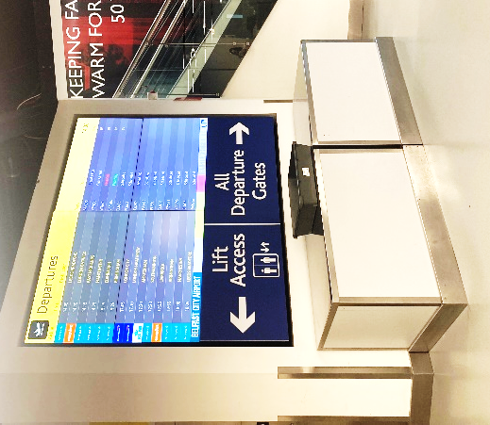

Recommendations:

- Consider additional signage to improve awareness of the seating area immediately after security.
- Implement colour contrasting at the desk/shelving areas where people gather their belongings after security.

The group noted that the lift in this area under the stairs did not have audio description. However, airport staff confirmed that audio was available in all other lifts.

Recommendation:

- Consider adding audio description and signage to the lift up to the departures lounge, to improve accessibility for passengers requiring this facility.

The availability of an alternative route to the departure lounge has been welcomed by the group as it allows passengers with sensory needs to bypass the busy shopping area. Larger signage would be useful in this area to indicate the alternative route. The shiny floor in the duty-free area, on the route to the departure lounge, can pose challenges for passengers with sight loss.

Recommendations:

- Consider installing larger signage indicating the alternative route to the departure lounge.
- Consider changing the floor in the duty-free area to one with contrasting colours to improve visibility for passengers with sight loss.

Gate area
Airport staff noted the new changes implemented in this area based on recommendations from the previous visit, including the addition of braille signage on the doors of the accessible toilets. However, the group thought the placement of this signage is too high (Figure 7).

Forum members welcomed the coloured seat and handles in the accessible bathroom. A group member suggested that a shelf be added to the bathroom for Stoma users.

Placing bins beside the toilets can be a barrier to people in wheelchairs needing to transfer to the toilet (Figure 8).

Members expressed concern that the doors in the toilet block in departures swing back open again which is an issue for visually impaired people (Figure 9).

Figure 7: Signage for accessible toilets

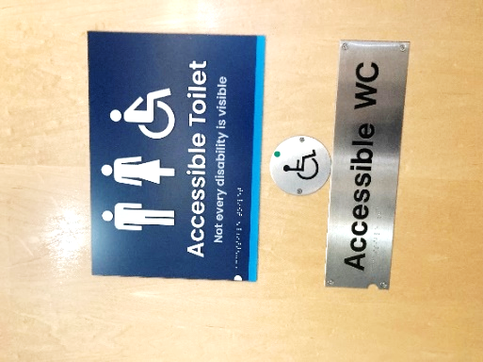

Figure 8: Bin placement causing potential barrier in accessible toilet

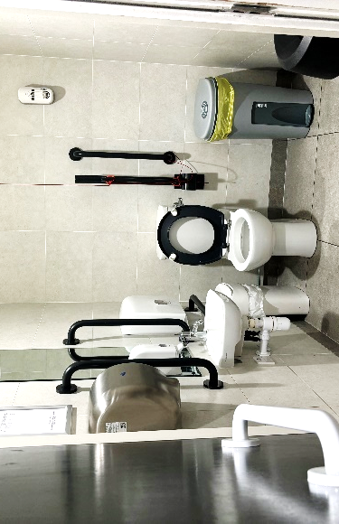

Figure 9: Toilet block in departure lounge - doors swing back when not locked

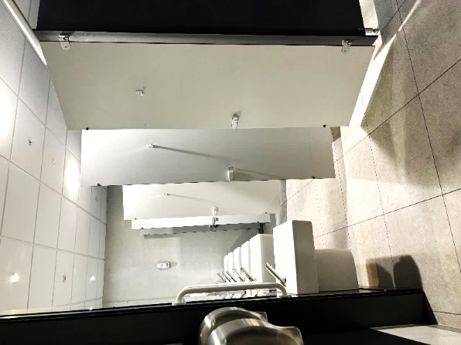

Recommendations:

- Lower the braille signage on all accessible toilet doors to enhance accessibility.
- Add a shelf for Stoma users in all accessible toilets throughout the airport.
- Consider adjusting toilet doors to ensure they do not swing back when not locked.
- Ensure cleaning staff are adequately trained regarding the placement of bins in the accessible toilets and conduct routine inspections to confirm that they do not create barriers for passengers.

Airport staff noted the relocation of the new large, assisted travel area to an improved location (Figure 10). The call button is clearly visible and unobstructed. Information on the CAA survey of the airport’s assistance services is highlighted on the screen low for passengers to view. The group commended the airport on these changes but raised concerns about other passengers using this area when it is busy. The group also noted concern that the cordon to mark off the area could be obstructive for those with sight loss, such as cane users.

Figure 10: Assisted travel seating area

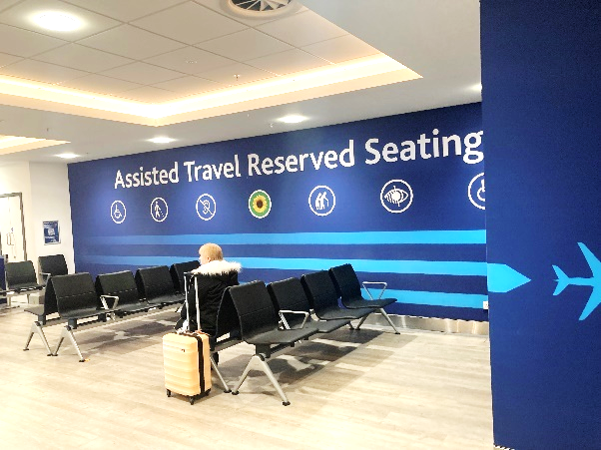

Recommendations:

- Consider removing the cordon to mark off the assisted travel seating area.
- Consider providing tactile flooring in the assisted travel seating area.
- Provide additional arms (which move up and down) to the seats in the assisted travel seating areas to improve accessibility and comfort.
- Review cordons throughout the airport to ensure these are only used where necessary and that the cordon colour contrasts well with the surrounding environment.

The group noted the improvements in the Danske Bank seating area, with the addition of portable chargers, lower desks, and plugs on the tables (Figure 11).

Figure 11: Departure seating area with portable charging

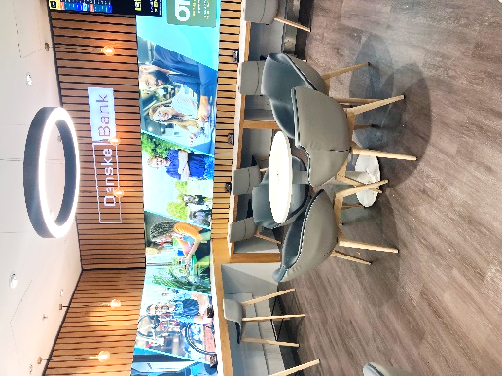

The group noted that the path to the tables/chairs in the ‘Coffee Café’ was narrow due to obstruction by a bin and a Christmas tree, which can be a barrier for accessibility (Figure 12).

Figure 12: ‘Coffee Café’ area

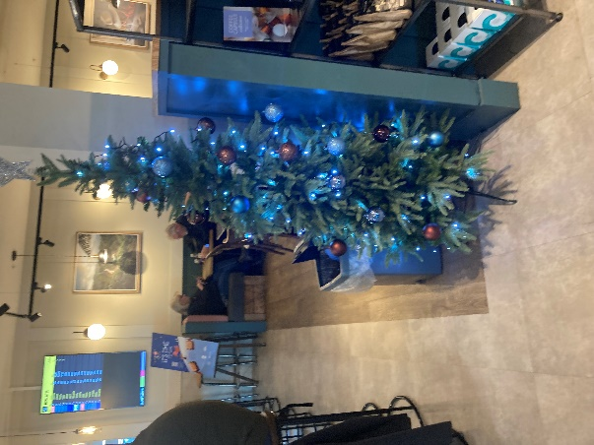

Recommendation:

- Relocate the bin and any other temporary items to ensure the area remains clear for wheelchair users.

Airport staff highlighted the changes made to the seating area in Starbucks Café. Countertop tables have been adjusted to a lower height and reduced in size to create additional space for wheelchair users (Figure 13).

Figure 13: Starbucks Café area

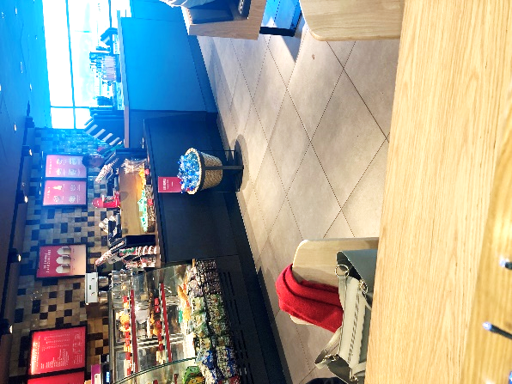

Airport staff highlighted the changes made to the Aspire Lounge after its refurbishment (Figure 14). The group welcomed the changes to improve accessibility, but concerns were raised that the chairs were the same colour as the walls in the seating area. The group also noted improvements which could be made to the accessible toilet in this area.

Figure 14: Aspire Lounge area

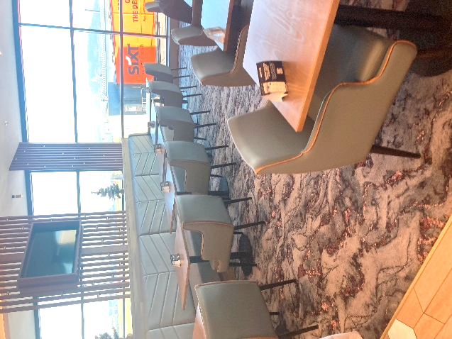

Recommendations:

- Change the colour of the seats in the Aspire Lounge to contrasting colours.
- An automatic door would be beneficial to access toilets.
- The grip handle should be lowered on the accessible toilet door.
- Consider making the accessible toilet larger to accommodate a wheelchair comfortably.
- It is important to provide seating with arms for accessibility purposes but consider relocating the arms from the end of the bench-style seating in the lounge/dining area to allow passengers to transfer from their wheelchair more easily.

Group members noted that the seating in the bar area is the same colour as the wall, creating difficulties for passengers with sight loss (Figure 15).

Figure 15: Seating in the bar area

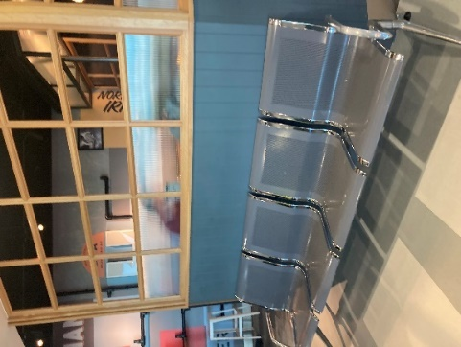

Recommendation:

- Consider implementing contrasting colours for the seating in the bar area to improve visibility.

It is important that yellow strips are placed at the top and bottom of all steps to improve visibility (Figure 16).

Figure 16: Steps down to Gates 1-3 and 5-10

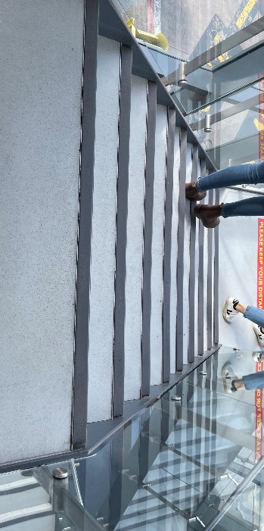

Recommendation:

- Implement yellow strips at the top and bottom of all steps throughout the airport.

Group members noted that the lifts required braille signage from Gate 1-10.

Recommendation:

- Add braille signage to the lifts from Gate 1-10.

Group members noted that the doors and door frames downstairs near gates 1-3 are the same colour. This lack of contrast may impact on passengers' visibility, particularly those with sight loss (Figure 17).

Figure 17: Doors at the entrance area

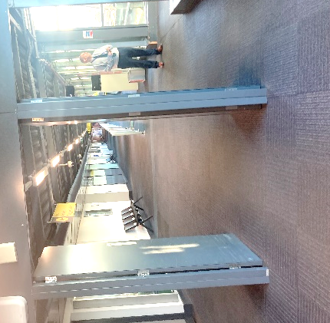

Recommendation:

- Implement contrasting colours for the doors and doorframes near Gate 1-3 to improve visibility.

There is a large amount of information posters at Border Control at International Arrivals (Figure 18). The group acknowledged that this is a legal requirement, but asked if consideration could be given to the positioning of the signage to improve accessibility of the information.

Figure 18: Information posters at Border Control

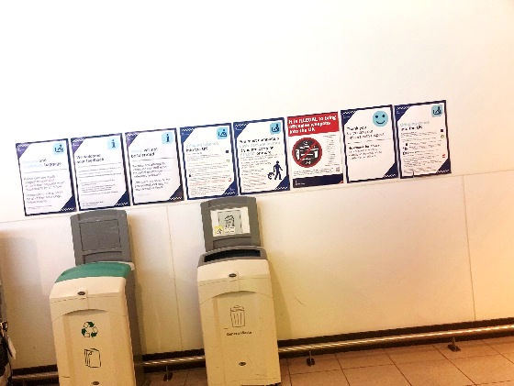

Recommendation:

- Give consideration to repositioning the information posters at Border Control for better visibility.

Group members noted that the accessible toilet in border control was a good example although there is no shelf which is especially useful for Stoma users.

Signposting to the toilets in the domestic arrivals area could be improved, as the arrow was pointing straight ahead rather than to the left (Figure 19).

The group noted that the height of the door handle on the exterior of the toilet differs from that on the interior, making it too high for wheelchair users. The position of the hand dryer could be reconsidered to improve accessibility.

Figure 19: Signage to the toilets in the domestic arrivals area

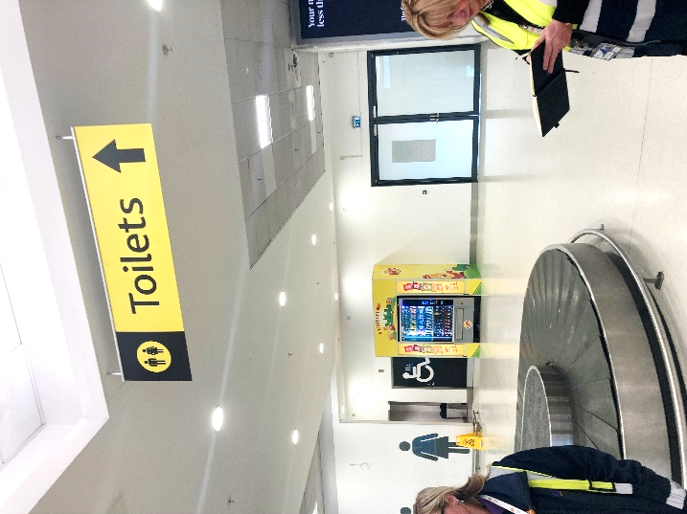

Recommendations:

- Amend the signage to the toilets in the domestic arrivals area by redirecting the arrow to ensure it accurately directs passengers.
- Consider relocating the hand dryer in the accessible toilets to beside the basin for better accessibility.
- Amend the height of the door handle in the accessible toilet to ensure it is within reach for wheelchair users.

Conclusion
Participants welcomed the opportunity to tour the airport and expressed satisfaction throughout at the processes and changes that had been implemented to improve the experience for passengers requiring special assistance. Participants were able to ask questions throughout the visit and make suggestions based on their experiences and knowledge of some of the barriers passengers may face. A number of further suggestions were made including placement of items in the accessible toilets, colour contrasting on chairs, doors, steps, and improvements to the Aspire Lounge.

Next Steps
The comments made by participants will be presented to the airport through this report. The Consumer Council will work with the airport as it implements the changes to ensure that services continue to meet passengers’ needs. An update on the progress made against the recommendations will be shared with the Airport’s Accessibility Forum at its next meeting.

Annex 1 Summary of Recommendations

Arrival at the airport/parking area
- Consider changing the colour of the “Disabled Assistance Point” sign to blue. This would contrast well with the yellow background.
- Consider moving the intercom to the entrance to the shelter (end of zebra crossing). Alternatively, provide additional signage at this point indicating the location of the existing push button or install an additional push button at the zebra crossing located at the end of the shelter.
- Add the telephone number for assistance to the airport website. This would be particularly beneficial for those who are unable to use the intercoms while waiting in the car.

Car Hire desks
- Consider provision of a lowered desk at each service provider to improve accessibility for all users.

Security area
- Consider further training for airport staff in dealing with passengers with different disabilities to ensure they are aware on how best to support passengers with the security process.

Signage
- Consider amending the main signage visible through the entrance doors to include the location of the Disability Services desk.
- Consider additional signage to improve awareness of the seating area immediately after security.
- Implement colour contrasting at the desk/shelving areas, where people gather their belongings after security.
- Consider adding audio description and signage to the lift up to the departures lounge, to improve accessibility for passengers requiring this facility.
- Consider installing larger signage indicating the alternative route to the departure lounge.
- Consider changing the floor in the duty-free area to one with contrasting colours to improve visibility for passengers with sight loss.
- Lower the braille signage on all accessible toilet doors to enhance accessibility.
- Consider implementing contrasting colours for the seating in the bar area, Aspire lounge and for the doors and doorframes near Gate 1-3 to improve visibility.
- Implement yellow strips at the top and bottom of all steps throughout the airport.
- Add braille signage to the lifts from Gate 1-10.
- Give consideration to repositioning the information posters at Border Control for better visibility.
- Amend the signage to the toilets in the domestic arrivals area by redirecting the arrow to ensure it accurately directs passengers.

Toilets
- Add a shelf for Stoma users in all accessible toilets throughout the airport.
- Consider adjusting toilet doors to ensure they do not swing back when not locked.
- Ensure cleaning staff are adequately trained regarding the placement of bins in the accessible toilets and conduct routine inspections to confirm that they do not create barriers for passengers.
- Consider relocating the hand dryer in the accessible toilets to beside the basin for better accessibility.
- Amend the height of the door handle in the accessible toilet (domestic arrivals area) to ensure it is within reach for wheelchair users.

The assisted travel seating area
- Consider removing the cordon to mark off the assisted travel seating area.
- Consider providing tactile flooring in the assisted travel seating area.
- Provide additional arms (which move up and down) to the seats in the assisted travel seating areas (both in the Departures lounge and in the area opposite Disability Services pre-security) to improve accessibility and comfort.
- Review cordons throughout the airport to ensure these are only used where necessary and that the cordon colour contrasts well with the surrounding environment.

Coffee café area
- Relocate the bin and any other temporary items to ensure the area remains clear for wheelchair users.

Aspire Lounge
- Change the colour of the seats in the Aspire Lounge to contrasting colours.
- An automatic door would be beneficial to access toilets
- The grip handle should be lowered on the accessible toilet door.
- Consider making the accessible toilet larger to accommodate a wheelchair comfortably.
- It is important to provide seating with arms for accessibility purposes but consider relocating the arms from the end of the bench-style seating in the lounge/dining area to allow passengers to transfer from their wheelchair more easily.


Consumer Council for Northern Ireland
Floor 3, Seatem House
28-32 Alfred Street
Belfast BT2 8EN
Freephone: 0800 121 6022
Email: contact@consumercouncil.org.uk
Website: www.consumercouncil.org.uk



